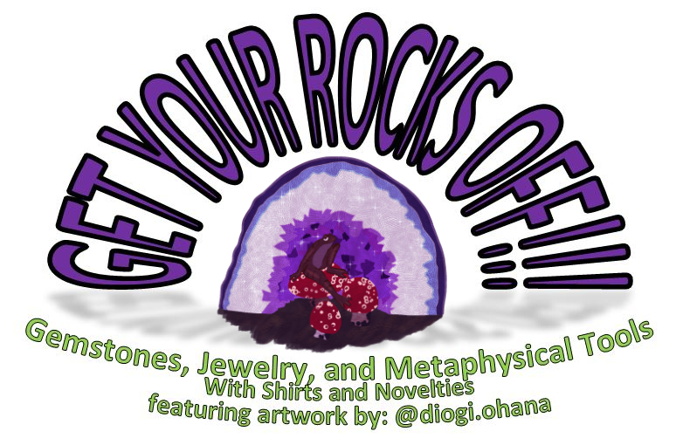
Chakra Bracelet
$15

www.getyourrocksoff.shop
@getyourrocksoffshop
Chakra Bracelet
$15

www.getyourrocksoff.shop
@getyourrocksoffshop
Chakra Necklace
$18

www.getyourrocksoff.shop
@getyourrocksoffshop
Chakra Earring and Bracelet Set
$25

www.getyourrocksoff.shop @getyourrocksoffshop
Chakra Bracelet
$15

www.getyourrocksoff.shop @getyourrocksoffshop
Chakra Bracelet
$15

www.getyourrocksoff.shop @getyourrocksoffshop

Chakra
Referencing and healing the energy centers from the base of the spine to the top of the head. Each chakra point is associated with a specific color, and gemstones of that color can be used to activate or treat them. Chakra therapy vitalizes and influences the physical, emotional, mental, and spiritual movements of the mind and body.

Base – Carnelian (Red)
Sacral – Tiger’s Eye
Solar Plexus – Yellow Carnelian (Yellow)
Heart – Malachite
Throat – Quartz (Blue)
Third Eye/Crown – Amethyst
Onyx
Quartz

Chakra
Referencing and healing the energy centers from the base of the spine to the top of the head. Each chakra point is associated with a specific color, and gemstones of that color can be used to activate or treat them. Chakra therapy vitalizes and influences the physical, emotional, mental, and spiritual movements of the mind and body.

Base – Red Agate
Sacral – Citrine
Solar Plexus – Tiger’s Eye
Heart – Aquamarine and Aventurine
Throat – Sodalite
Third Eye – Jasper (Mookaite)
Crown – Amethyst

Chakra
Referencing and healing the energy centers from the base of the spine to the top of the head. Each chakra point is associated with a specific color, and gemstones of that color can be used to activate or treat them. Chakra therapy vitalizes and influences the physical, emotional, mental, and spiritual movements of the mind and body.

Base – Garnet
Sacral – Carnelian
Solar Plexus – Tiger’s Eye
Heart – Malachite
Throat – Sodalite
Third Eye – Jasper (Mookaite)
Crown – Amethyst
Onyx

Chakra
Referencing and healing the energy centers from the base of the spine to the top of the head. Each chakra point is associated with a specific color, and gemstones of that color can be used to activate or treat them. Chakra therapy vitalizes and influences the physical, emotional, mental, and spiritual movements of the mind and body.

Base – Red Agate
Sacral – Carnelian
Solar Plexus – Citrine
Heart – Aventurine (Green)/Apatite
Throat – Sodalite
Third Eye/Crown – Amethyst
Quartz (Smokey)
Quartz

Chakra
Referencing and healing the energy centers from the base of the spine to the top of the head. Each chakra point is associated with a specific color, and gemstones of that color can be used to activate or treat them. Chakra therapy vitalizes and influences the physical, emotional, mental, and spiritual movements of the mind and body.

Base – Carnelian (Red)
Sacral – Carnelian (Orange/Yellow)
Solar Plexus – Tiger’s Eye
Heart – Malachite
Throat – Quartz (Blue)
Third Eye /Crown – Amethyst
Onyx

Chakra
Referencing and healing the energy centers from the base of the spine to the top of the head. Each chakra point is associated with a specific color, and gemstones of that color can be used to activate or treat them. Chakra therapy vitalizes and influences the physical, emotional, mental, and spiritual movements of the mind and body.

Base – Red Agate
Sacral – Jasper (Yellow)
Solar Plexus – Tiger’s Eye
Heart – Malachite
Throat – Sodalite
Third Eye – Jasper (Mookaite)
Crown – Amethyst
Quartz
Onyx

